**Glossary Technical Test**

**Prerequisites**

* Visual Studio Visual Studio 2019 Community Edition
* Visual Studio Visual Code
* Latest Node.JS
* Latest Angular CLI

**Description**

The application has been developed by using Asp .Net Core 3.1 and Angular 9. It demonstrates how SPA Angular 9 application interacts with restful Asp .Net Core Web Api service. Client and server-side validations added. Unit tests/integration tests for front and back end code are also implemented.

**How to Run**

“Part A.” and “Part B” solutions have been implemented. So please open corresponding solution files in visual studio. You can run unit and integration tests in the test runner.

Please make sure that Glossary.Api project is up and running on <https://localhost:5001> first. By default, if you run the api project from Visual Studio, <https://localhost:5001/swagger> will be opened in browser.

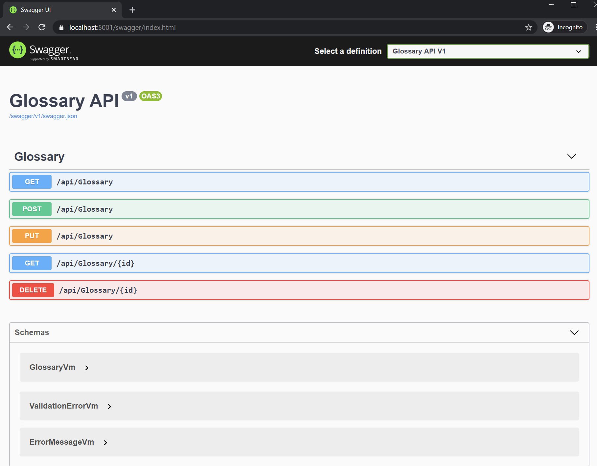

In order to run “Part B” Angular application please open “**Part B\Glossary.UI**” folder in Visual Studio Code and run **“npm start“** command. After that a local development web server runs and you can navigate the application on <http://localhost:4200> in the browser.

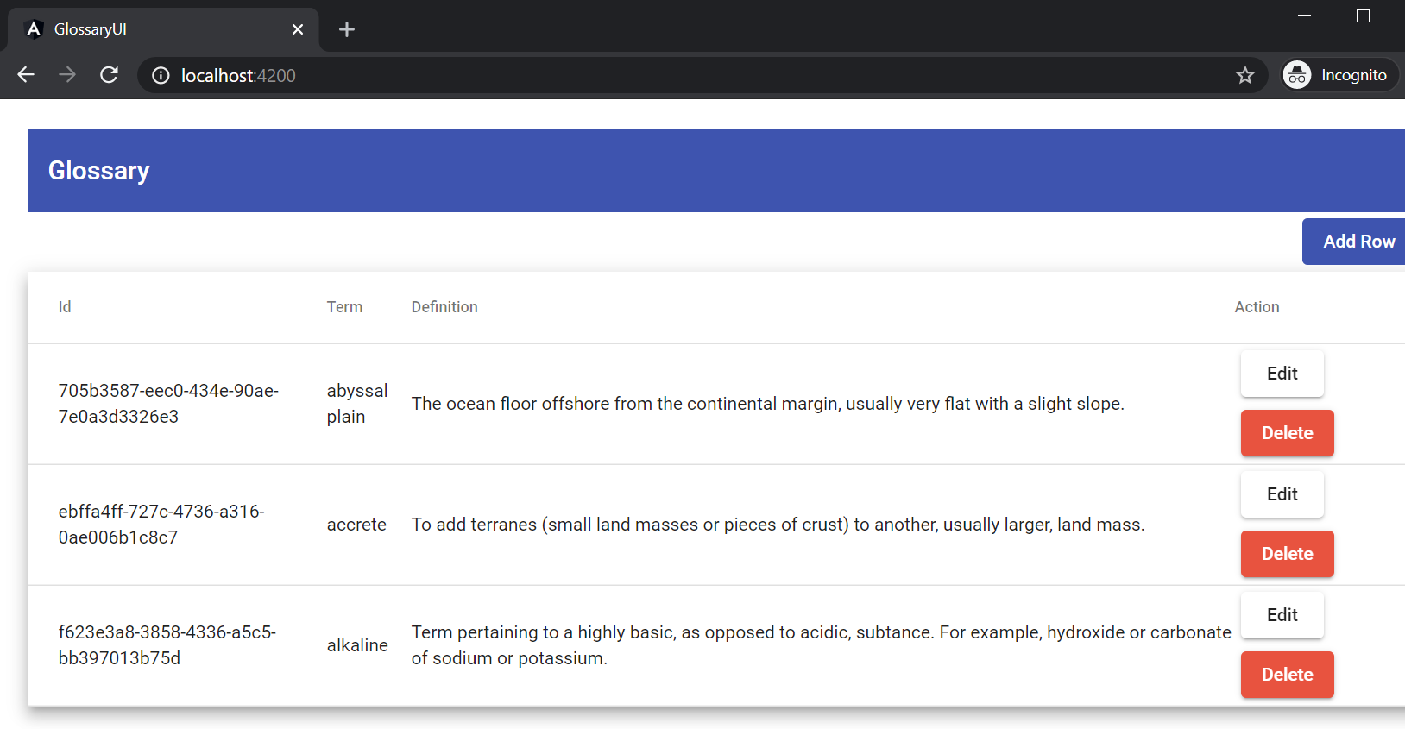

In order to run jasmine front-end code unit tests please run "**npm test".**